LED Curtain Lights

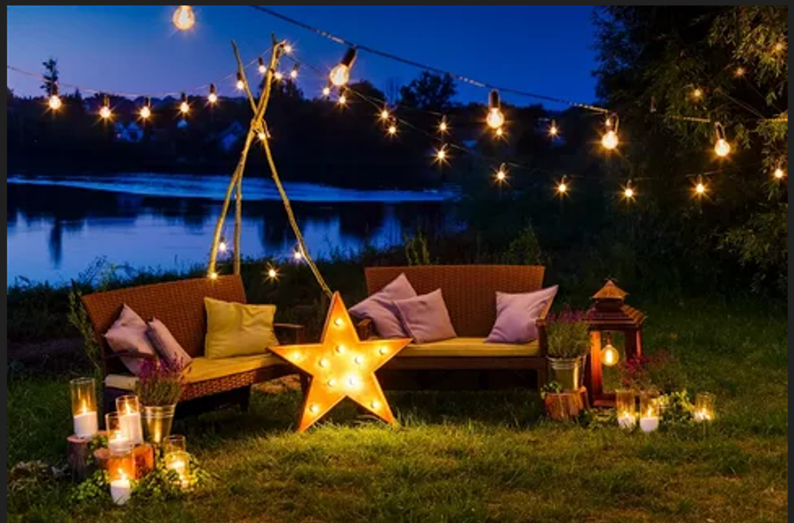

#### ****Description:****

**LED Curtain Lights** are stunning, energy-efficient lighting solutions designed to create a dazzling display of light. These lights are perfect for adding a festive and magical touch to both indoor and outdoor spaces. With their cascading design and customizable settings, LED Curtain Lights are ideal for weddings, parties, home decor, and commercial displays.

* **Technology:** LED.
* **Power Source:** Plug-in or battery-operated (depending on the model).
* **Bulb Type:** Mini LED bulbs.
* **Wattage:** 10W (plug-in), 5W (battery-operated).
* **Lumens:** 20 lumens per bulb.
* **Color Options:** Warm white, cool white, multicolor.
* **Dimmable:** No.
* **Lifespan:** 20,000 hours.
* **Energy Efficiency:** Energy-efficient LED technology.
* **Weather Resistance:** IP44 rated (splash-proof for outdoor use).

#### ****Key Features:****

* **Cascading Design:** Creates a stunning waterfall effect of light.
* **Energy-Efficient:** Uses LED technology for long-lasting and energy-saving performance.
* **Versatile Use:** Suitable for indoor and outdoor settings, including weddings, parties, and home decor.
* **Customizable Settings:** Multiple lighting modes (steady, flashing, fading, etc.).
* **Weather-Resistant:** Splash-proof design for outdoor use.
* **Easy Installation:** Comes with hooks or clips for easy hanging.

#### ****Pricing:****

* **6.5-Foot x 6.5-Foot Plug-In LED Curtain Lights:** $39.99
* **6.5-Foot x 6.5-Foot Battery-Operated LED Curtain Lights:** $49.99
* **10-Foot x 10-Foot Plug-In LED Curtain Lights:** $59.99
* **10-Foot x 10-Foot Battery-Operated LED Curtain Lights:** $69.99

#### ****Where to Use:****

* **Weddings:** Create a romantic backdrop for ceremonies and receptions.
* **Parties:** Add a festive touch to indoor and outdoor celebrations.
* **Home Decor:** Enhance living rooms, patios, and balconies with a dazzling display.
* **Commercial Displays:** Highlight storefronts, events, and promotional setups.
* **Outdoor Spaces:** Illuminate gardens, fences, and outdoor decor.

### ****Customer Reviews:****

* ⭐⭐⭐⭐⭐ "These LED Curtain Lights are absolutely stunning! They create a magical atmosphere for my outdoor parties and weddings." – Sarah L.
* ⭐⭐⭐⭐ "Great value for the price. The lights are bright, and the multiple lighting modes add a fun touch to any event." – James T.
* ⭐⭐⭐⭐⭐ "I love how energy-efficient these lights are. The cascading design is perfect for creating a festive ambiance." – Emily R.

### ****How to Order:****

1. Visit our website: [www.brightworldlighting.com](http://www.brightworldlighting.com/)
2. Select your preferred size and power source (Plug-In or Battery-Operated).
3. Add to cart and proceed to checkout.
4. Enjoy free shipping on all orders over $50!

### ****Warranty and Support:****

* **Warranty:** 1-year limited warranty covering manufacturing defects.
* **Customer Support:** Contact us at [support@brightworldlighting.com](mailto:support@brightworldlighting.com) or call +1-800-123-4567 for assistance.

### ****Visual Representation:****

Include high-quality images of the LED Curtain Lights in different settings (e.g., weddings, outdoor parties) to showcase their versatility and design.